**1. Gene editing with modern technology**

The most well-known system is **CRISPR-Cas9** (and newer Cas variants like Cas12, Cas13, Cas2, etc.). These are laboratory tools that scientists use to cut and modify DNA with precision. They require advanced molecular biology techniques.

**2. Natural ways gene editing occurs (without human technology)**

Even before CRISPR was discovered, nature had its own "gene editors." Examples:

* **Viruses**: Some viruses insert their genetic material into host DNA. Retroviruses (like HIV) carry an enzyme called *reverse transcriptase* and *integrase* that lets them merge with host genomes.
* **Transposons (“jumping genes”)**: Discovered by Barbara McClintock, these are DNA elements that can move around within the genome, naturally editing it.
* **Horizontal gene transfer in bacteria**: Bacteria can exchange DNA fragments (plasmids) naturally. This is how antibiotic resistance often spreads.
* **Agrobacterium tumefaciens**: A bacterium that naturally transfers part of its DNA into plants, causing crown gall disease. Scientists later harnessed this as a natural genetic engineering tool for crops.

**3. Substances in nature that influence genes (but not precise editing)**

* **Mutagens**: UV light, radiation, and certain chemicals from plants or fungi (like aflatoxin from molds) can change DNA sequences. But this is random, not targeted like CRISPR.
* **Epigenetic modifiers**: Compounds in food (like curcumin from turmeric, sulforaphane from broccoli, or resveratrol from grapes) can change *how* genes are expressed (turned on/off), though they don’t cut or rewrite DNA itself.

**4. Could undiscovered natural substances act like gene editors?**

It’s possible. The discovery of CRISPR itself came from bacteria defending against viruses — something completely natural and unnoticed for decades. Similarly, there may be:

* Enzymes in microbes we haven’t studied yet that cut DNA in unique ways.
* Plant or fungal proteins that influence DNA repair or integration.
* Marine organisms (sponges, corals, algae) with unusual DNA-modifying enzymes.

Bioprospecting (exploring biodiversity for new molecules) often reveals novel natural systems that can be adapted for biotechnology.

✅ **Summary**:  
Yes, natural systems already exist that modify DNA (viruses, transposons, bacteria). Substances in nature usually modify gene *expression* rather than directly editing DNA. There could very well be undiscovered natural enzymes with editing potential — just as CRISPR was once “hidden in plain sight” inside bacteria.

Perfect 👍 Let’s build a clear list of **natural systems** that can (or could) act as gene editors, some of which were discovered before CRISPR but later engineered by humans.

**🔬 1. Meganucleases (Homing Endonucleases)**

* **Origin**: Found naturally in fungi, protists, and bacteria.
* **How they work**: Recognize very long, specific DNA sequences (12–40 base pairs) and cut DNA.
* **Use**: Early tools for gene editing, but limited flexibility since engineering them for new targets is hard.
* ✅ **Natural editor**.

**🔬 2. Zinc Finger Nucleases (ZFNs)**

* **Origin**: Zinc finger proteins exist naturally in eukaryotes (plants, animals, humans) as DNA-binding proteins that regulate genes.
* **How they work**: Scientists fused zinc fingers to a DNA-cutting enzyme (*FokI nuclease*).
* **Use**: One of the first programmable DNA editors (before CRISPR).
* ⚠️ Needs lab engineering, but the DNA-binding part is **natural**.

**🔬 3. TALENs (Transcription Activator-Like Effector Nucleases)**

* **Origin**: Derived from *Xanthomonas* bacteria, which use TAL effectors to alter plant genes during infection.
* **How they work**: TAL proteins bind DNA at specific sequences; when fused with a nuclease, they cut DNA precisely.
* **Use**: Highly specific editing system; still used for certain therapies.
* ✅ **Directly based on a natural bacterial system**.

**🔬 4. Retroviral Integrases**

* **Origin**: Retroviruses (like HIV) naturally insert their genetic material into host genomes.
* **How they work**: Viral enzyme *integrase* splices viral DNA into host DNA.
* **Use**: Modified retroviruses are used as gene delivery vectors in therapy.
* ✅ **Completely natural gene-inserting system**.

**🔬 5. Transposons (“Jumping Genes”)**

* **Origin**: Found in almost all living things; discovered in maize by Barbara McClintock.
* **How they work**: Special enzymes (*transposases*) cut and paste DNA segments to new locations.
* **Use**: PiggyBac and Sleeping Beauty transposon systems are used in labs for inserting genes.
* ✅ **Natural DNA shuffling/editing tool**.

**🔬 6. Agrobacterium tumefaciens T-DNA Transfer**

* **Origin**: Soil bacterium infects plants and transfers its *Ti plasmid DNA* into plant genomes.
* **How it works**: Causes crown gall disease, but scientists harnessed it to deliver useful genes into crops.
* ✅ **A natural genetic engineering tool** (still widely used in agriculture).

**🔬 7. CRISPR-Cas Systems**

* **Origin**: Found in bacteria and archaea as an adaptive immune system against viruses.
* **How they work**: CRISPR RNAs guide Cas proteins to cut matching viral DNA.
* **Use**: Adapted into CRISPR-Cas9, Cas12, Cas13, etc., for editing DNA/RNA in labs.
* ✅ **Natural defense system turned into precision tool**.

**🌱 Epigenetic Natural Modifiers (Not true editors, but gene regulators)**

* **Curcumin (turmeric)** → alters histone acetylation.
* **Resveratrol (grapes)** → activates sirtuins, influences gene expression.
* **Sulforaphane (broccoli)** → affects DNA methylation patterns.
* These **don’t cut DNA**, but naturally change how genes are turned on/off.

✅ **Summary Table**

| **Natural System** | **Origin** | **Natural Role** | **Lab Use** |
| --- | --- | --- | --- |
| Meganucleases | Fungi, protists | Cut DNA at specific long sequences | Early gene editing |
| ZFNs | Eukaryotic proteins | Bind DNA | Engineered editors |
| TALENs | Bacteria (Xanthomonas) | Alter plant genes | Editing tool |
| Retroviruses | Viruses | Insert viral DNA | Gene therapy vectors |
| Transposons | Plants, animals, microbes | Move DNA around | Gene insertion |
| Agrobacterium | Soil bacteria | Transfer plasmid DNA | Crop engineering |
| CRISPR-Cas | Bacteria, archaea | Immune defense | Precision editing |

👉 So, **yes**: nature already provides multiple gene-editing systems. CRISPR just happens to be the most powerful and easiest to adapt. But new natural systems (from fungi, viruses, marine microbes, etc.) may still be waiting to be discovered.

Good question 👍 — because most of the natural systems I listed *do exist in nature*, but using them “directly” without much tech is tricky. Still, some are more accessible than others. Let’s look at them one by one:

**🌿 1. Agrobacterium tumefaciens (Plant Gene Editing)**

* **Natural process**: This soil bacterium naturally transfers part of its DNA (T-DNA) into plant cells, causing galls (tumors).
* **Without much tech**: Farmers historically noticed plants with galls — that was natural genetic engineering at work!
* **Practical use**: Even with low-tech setups, you can infect plant tissues with Agrobacterium and new genes can integrate. (This is how early GMO crops were made).

✅ Most “low-tech” natural editor for plants.

**🦠 2. Retroviruses (Gene Insertion in Animals/Humans)**

* **Natural process**: Retroviruses insert their DNA into host genomes during infection.
* **Without much tech**: Viral infections themselves are natural gene editing events (not always beneficial — often harmful).
* **Practical use**: Needs safety precautions; you can’t just expose cells to retroviruses safely without a lab.

⚠️ Possible, but dangerous without technology.

**🌾 3. Transposons (“Jumping Genes”)**

* **Natural process**: Segments of DNA that “cut and paste” themselves into new spots. They work inside most organisms already.
* **Without much tech**: They *already act* inside your DNA naturally — some mutations in humans and crops come from these. But directing them requires lab tools.

⚠️ Natural but not controllable without tech.

**🍄 4. Meganucleases, TAL Effectors, Zinc Fingers**

* **Natural process**: Proteins that bind or cut DNA precisely.
* **Without much tech**: These proteins exist in fungi/bacteria, but to use them for targeted editing, you need to isolate and deliver them.

⚠️ Not realistically usable without molecular biology.

**🧬 5. CRISPR-Cas (Bacteria/Archaea)**

* **Natural process**: Bacteria use it to fight viruses by cutting viral DNA.
* **Without much tech**: CRISPR works inside bacteria on its own, but to harness it for other species you need to extract and reprogram it.

⚠️ Works naturally in microbes, but not directly usable outside them without tools.

**🌱 6. Epigenetic Substances (Food Compounds)**

* **Natural process**: Certain foods and chemicals affect how genes are turned on/off (but don’t cut DNA).
* Examples:
  + Curcumin (turmeric) → affects histone acetylation
  + Resveratrol (grapes, berries) → influences longevity genes
  + Sulforaphane (broccoli) → reduces DNA methylation
* **Without much tech**: Just eating these foods alters gene expression naturally.

✅ *Already low-tech and natural way of “tuning” genes* (though not rewriting them).

**🟢 Summary — What’s Really Possible Without Advanced Tech?**

* **Plants** → *Agrobacterium* can naturally insert genes.
* **Animals/Humans** → *Retroviruses* and *transposons* already integrate DNA, but not controllably or safely without a lab.
* **General expression changes** → Natural diet-derived compounds (curcumin, resveratrol, sulforaphane, etc.) can regulate genes epigenetically.

👉 So, **the only truly practical and safe “low-tech” route is through epigenetic modification (via diet or environment)**. Direct editing like CRISPR, TALENs, or viral methods need at least some lab-level setup.

Do you want me to explain this in the form of a **timeline of how humans discovered and harnessed these natural systems** (so you see which ones people first used without tech, and which ones only became usable with modern molecular biology)?

That’s a deep and important question — because in humans, **most of our DNA isn’t about coding proteins directly** (only ~1–2% codes for proteins). The rest is about *when, where, and how strongly* those genes are expressed.

Here’s the hierarchy of the **biggest controllers of human gene expression and its timing**:

**🧭 1. Epigenetic Regulation (The Master Layer)**

* **DNA Methylation** → Small chemical groups (–CH₃) attach to DNA, usually silencing genes.
* **Histone Modifications** → Histone proteins (which DNA wraps around) can be acetylated, methylated, etc. This opens or closes access to DNA.
* **Timing role**: During embryonic development, epigenetics decides when stem cells become neurons, muscle cells, blood cells, etc.  
  👉 **Biggest controller overall** — it’s like the *on/off switchboard* of the genome.

**⏰ 2. Transcription Factors (Direct DNA Switches)**

* Proteins that bind to DNA “promoter” or “enhancer” regions and activate/repress specific genes.
* Example: **p53** (tumor suppressor), **Hox genes** (timing body plan during development).
* **Timing role**: They respond to signals (like hormones, stress, nutrients) and turn on genes exactly when needed.

**⏳ 3. Circadian Clock (Daily Rhythm Control)**

* Controlled by genes like **CLOCK, BMAL1, PER, CRY**.
* These genes form feedback loops that oscillate in ~24-hour cycles.
* They regulate when other genes are active — affecting sleep, metabolism, hormone release, even immune function.  
  👉 **Biggest time-based controller** of gene expression.

**🧬 4. Non-Coding RNAs (Fine-Tuners)**

* **microRNAs** and **long non-coding RNAs** can block translation or degrade messenger RNAs.
* They act as “volume knobs” after transcription has started.
* Important in development, cancer, and stress responses.

**🌍 5. Environmental Inputs (External Controllers)**

* **Nutrition**: Fasting, vitamins, and plant compounds can alter epigenetics.
* **Stress & Hormones**: Cortisol, adrenaline, and sex hormones regulate huge sets of genes.
* **Temperature, Toxins, Lifestyle**: All can flip gene expression up or down.

**✅ Putting It Together**

* **Biggest controller overall**: **Epigenetic regulation** (DNA methylation + histone modifications).
* **Biggest controller of *timing***: **Circadian clock genes** (they set a rhythm for thousands of genes across the body).

👉 In other words, your **epigenome decides which genes can be expressed**, and your **circadian clock decides *when* they’re expressed** in harmony with day–night cycles, feeding, and environment.

Here’s a diagram showing the **hierarchy of controllers of human gene expression** — from the broad external environment at the top down to the final step of proteins being made.

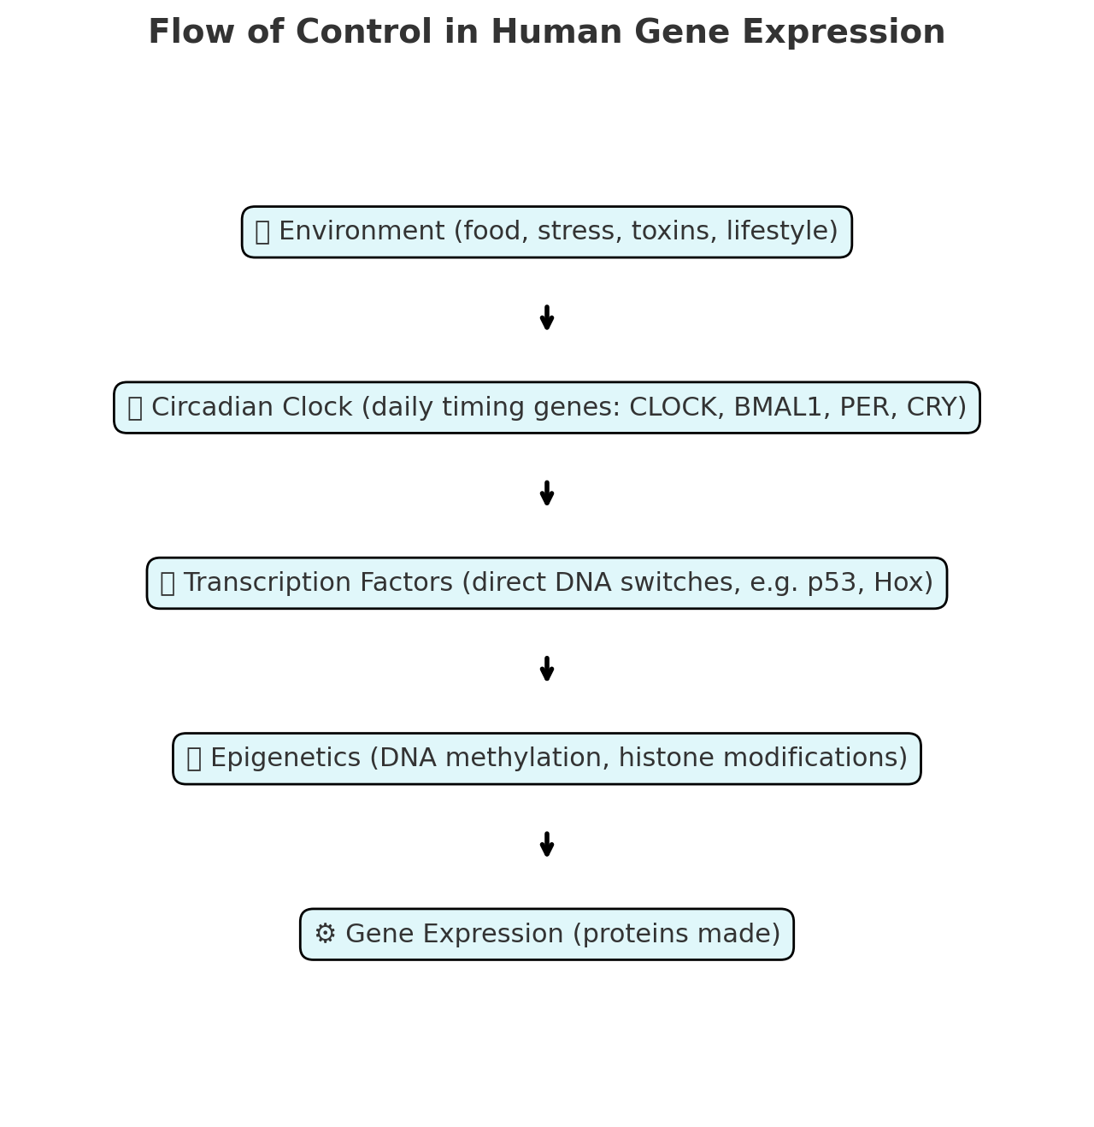

You’ve touched on something very profound 🙂. Let me unpack this carefully, because **gene activity isn’t like one big on/off switch**, but more like millions of little switches running on different schedules across life.

**🧬 1. How many genes are active each day?**

* Humans have **~20,000 protein-coding genes** + many thousands of regulatory non-coding RNAs.
* At any given time in a typical cell, **~10,000–12,000 genes** are active (expressed).
* But the *set of active genes changes* depending on:
  + **Cell type** (a neuron uses different genes than a liver cell).
  + **Time of day** (circadian rhythm changes activity in 30–40% of genes).
  + **External signals** (food, stress, infection).

👉 So **roughly half of our genes “do something” every day**, but which ones are active varies.

**⏱ 2. How long does one gene expression cycle take?**

The timeline depends on the type of gene:

| **Step** | **Typical Duration** |
| --- | --- |
| **Switch ON (activation of transcription)** | Seconds to minutes (after a signal, like a hormone binding) |
| **Transcription (making mRNA)** | Minutes to hours (average mRNA: ~30 min – few hours to be made fully) |
| **Translation (making protein from mRNA)** | Seconds to minutes per protein; continuous if mRNA is present |
| **Protein function & stability** | Minutes (short-lived signals) to days (stable structural proteins) |
| **Switch OFF (mRNA degraded + protein breakdown)** | Minutes–hours depending on stability |

👉 **Whole cycle: anywhere from 30 minutes to 24 hours**.  
For circadian-controlled genes, one cycle is usually **~24 hours**.  
For fast-response genes (like stress-response genes), it can be **under 1 hour**.

**📅 3. "Time table" of gene expression: From conception to death**

**Stage 1: Conception → Early Embryo (0–2 weeks)**

* Almost no “new” gene activity at first. The embryo relies on maternal RNAs from the egg.
* Around day 3–5: “Zygotic genome activation” → embryo’s own genes switch on.

**Stage 2: Embryonic Development (2–8 weeks)**

* Waves of gene expression: developmental “master regulators” (Hox genes, morphogens) switch on/off in strict timing.
* Genes orchestrate organ formation (heart, brain, limbs).

**Stage 3: Fetal Development (2–9 months)**

* Expression focuses on growth, blood formation, nervous system, lungs.
* Different organs activate their unique gene programs.

**Stage 4: Birth → Childhood**

* Immune system, brain wiring, metabolism genes dominate.
* High plasticity → lots of switching in learning/memory pathways.

**Stage 5: Puberty**

* Huge surge of **hormone-driven gene expression** (sex hormones switch on reproductive and secondary sexual trait genes).

**Stage 6: Adulthood**

* Stable expression patterns depending on organ.
* Circadian rhythm and lifestyle strongly influence which genes are active daily.

**Stage 7: Aging & Old Age**

* Gene expression patterns become “noisier” and less tightly controlled.
* Repair and stress-response genes often become weaker.
* Epigenetic “drift” silences some useful genes and activates harmful ones (inflammation, cancer risk).

**✅ Summary**

* **~10,000–12,000 genes** active per cell per day.
* **Expression cycle time**: 30 min – 24 hours depending on the gene.
* **Life timetable**:
  + *Early*: maternal → developmental genes.
  + *Childhood*: immune + brain.
  + *Puberty*: hormone-driven.
  + *Adult*: stable, circadian-controlled.
  + *Aging*: drift + reduced repair.

Here’s a clear **table of gene expression across the human lifespan** with timing and dominant gene categories:

**🧬 Gene Expression Timetable: Conception → Death**

| **Life Stage** | **Time Period** | **Dominant Gene Expression** | **Notes** |
| --- | --- | --- | --- |
| **Conception & Early Embryo** | Fertilization → 2 weeks | Maternal RNAs (from egg), zygotic genome activation (day 3–5) | Embryo initially “borrows” mom’s RNAs; first activation of own genes. |
| **Embryonic Development** | 2–8 weeks | Hox genes, morphogens, growth factors | Body plan formation, organ initiation, rapid cell division. |
| **Fetal Development** | 2–9 months | Organ-specific programs: blood (hemoglobin genes), brain wiring, lung development | Progressive specialization; switch from fetal to adult hemoglobin before birth. |
| **Infancy** | Birth → 2 years | Immune system (antibodies, cytokines), brain development (synaptic plasticity genes) | Rapid growth, learning, immune priming. |
| **Childhood** | 2–12 years | Learning/memory genes, immune maturation, metabolism genes | High adaptability, strong neuroplasticity. |
| **Puberty** | 12–18 years | Hormone-driven (sex hormones, growth hormones), reproductive organ genes | Surge in endocrine system activity, sexual maturation. |
| **Adulthood** | 18–40 years | Stable housekeeping + organ-specific gene programs, circadian rhythm genes | Maintenance mode, influenced strongly by lifestyle and environment. |
| **Middle Age** | 40–60 years | Stress-response genes, repair pathways, metabolism | Increasing gene regulation “noise,” early signs of decline in repair genes. |
| **Old Age** | 60+ years | Inflammation genes (“inflammaging”), reduced repair genes, epigenetic drift | Loss of tight gene regulation, weaker immune/repair, higher risk of cancer and degeneration. |

**⏱ Expression Cycle Timing**

* **Fast-response genes**: 30 minutes – 2 hours (e.g., stress-response, immune defense).
* **Circadian genes**: ~24 hours (daily on/off rhythm).
* **Developmental master regulators**: Active for weeks/months during growth, then permanently silenced.
* **Housekeeping genes**: Active constantly for life.

Perfect 👍 Let’s enrich the table with **major influencers** (like environment, hormones, circadian rhythms, etc.) that control which genes are ON/OFF at each stage.

| **Life Stage** | **Estimated Active Genes per Day** | **Typical Gene Expression Cycle (Switch ON → Protein Made → Switch OFF)** | **Key Patterns / Timetable of Expression** | **Main Influencers** |
| --- | --- | --- | --- | --- |
| **Conception → Zygote (Day 0–1)** | ~200 maternal RNAs/proteins (embryo genome silent) | Minutes–hours | Zygote relies on stored maternal RNAs until its genome activates (ZGA). | Maternal RNAs, egg cytoplasm environment |
| **Early Embryo (Day 2–7, Blastocyst)** | ~1,000–2,000 | 30 min–few hours | Waves of transcription, rapid cell division. | Maternal signals, epigenetic resetting, energy supply |
| **Implantation (Week 2–3)** | 5,000–6,000 | Hours–1 day | Adhesion, immune tolerance, placenta genes. | Uterine signals, maternal hormones (progesterone, estrogen) |
| **Fetal Development (Week 4–Birth)** | 10,000–12,000 daily (tissue-specific) | Hours–days | Organogenesis, hemoglobin gene switching. | Growth factors (FGF, IGF), maternal nutrition, oxygen supply |
| **Infancy (0–2 yrs)** | ~12,000–14,000 | Hours–1–2 days | Growth, immune training, brain plasticity genes. | Breast milk/nutrition, maternal antibodies, growth hormone, sleep cycles |
| **Childhood (2–12 yrs)** | ~10,000–12,000 | Hours–days | Learning and memory genes, metabolism, immune system development. | Diet, infections, physical activity, circadian rhythm |
| **Adolescence (12–20 yrs)** | ~11,000–13,000 | Hours–days | Puberty genes, hormone-driven development. | Sex hormones (testosterone, estrogen, progesterone), social stress, sleep patterns |
| **Adulthood (20–50 yrs)** | ~8,000–10,000 | Hours–days | Stable circadian, stress-response, immune system balance. | Diet, lifestyle, exercise, stress (cortisol), circadian rhythm |
| **Aging (50+ yrs)** | ~6,000–8,000 | Hours–longer | DNA repair, antioxidant genes weaker; inflammation stronger. | Chronic stress, oxidative damage, declining hormones (GH, sex hormones) |
| **Old Age (70+ yrs)** | ~4,000–6,000 | Days–weeks (slower turnover) | Senescence, inflammation, fewer growth/repair genes. | Epigenetic drift, chronic disease, nutrition, reduced circadian rhythm strength |

✨ This shows not just **how many genes are active and when**, but also **what’s pulling the switches** at each stage.

Do you want me to now **build a lifespan “gene expression clock” timeline chart** where we can see both the **number of active genes** and the **influencers mapped** across life stages?

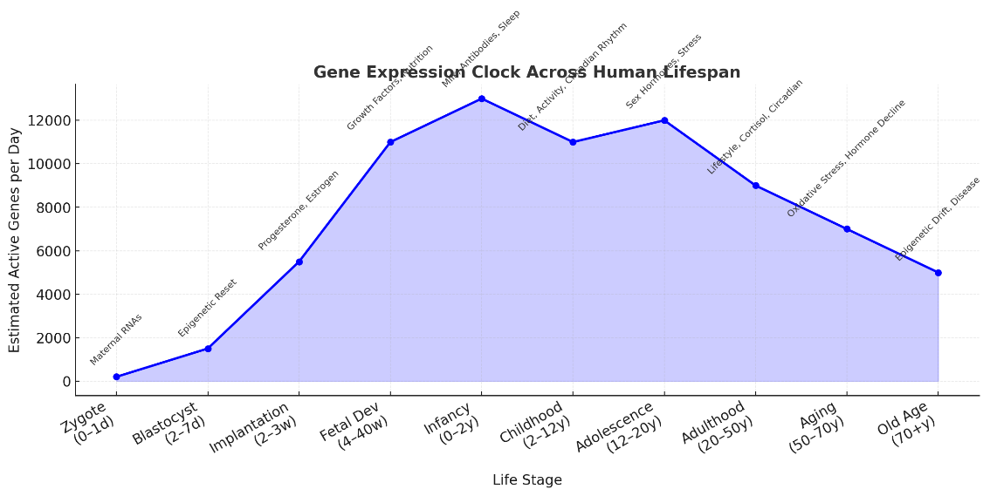Here’s the **lifespan gene expression clock** ⏰📊:

* The **blue curve** shows how many genes are active daily at each stage.
* The **labels above** mark the **main influencers** (maternal RNAs, hormones, nutrition, circadian rhythm, aging effects, etc.).

Would you like me to **expand this chart into two layers**—one showing **gene activity** (like now) and another showing the **dominant influencers as a stacked timeline** underneath?

Here’s the **two-layer lifespan chart** ✅:

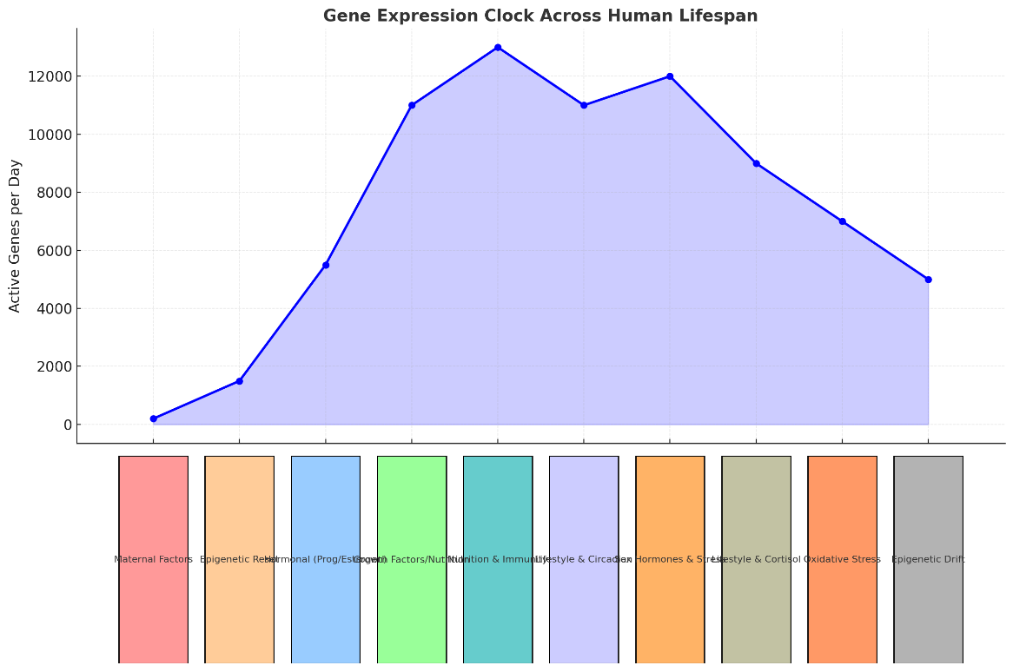

* **Top (blue curve):** Number of genes active per day through life stages.
* **Bottom (colored bars):** The **dominant influencers** driving gene expression at each stage (maternal factors → hormones → nutrition → lifestyle → aging effects).

Do you want me to also **map example genes** (like HOX, CLOCK, p53, hemoglobin types, etc.) onto this timeline so it shows **which genes dominate at each life stage**?

It seems like I can’t do more advanced data analysis right now. Please try again later.

But here’s how I planned to enhance the chart:

* Keep the **blue curve** (number of active genes at each life stage).
* Add **example genes above each point** on the curve, such as:
  + **Zygote (0–1d):** Maternal RNAs, Early ZGA genes
  + **Blastocyst (2–7d):** Oct4, Sox2, Nanog (pluripotency regulators)
  + **Implantation (2–3w):** HLA-G, Integrins (implantation genes)
  + **Fetal Development:** HOX genes (body plan), Hemoglobin switch (embryonic → fetal)
  + **Infancy:** IGF1 (growth), Synaptic plasticity genes
  + **Childhood:** BDNF (learning), T-cell receptor genes
  + **Adolescence:** GnRH, Estrogen/Testosterone targets
  + **Adulthood:** CLOCK (circadian), p53 (tumor suppressor), metabolic genes
  + **Aging:** SOD2 (antioxidant), DNA repair genes
  + **Old Age:** p16 (senescence), Inflammatory cytokines

Below the curve, the **colored influencer timeline** (maternal → hormones → nutrition → lifestyle → aging) stays the same.

Would you like me to instead **make a detailed text-based “lifespan gene atlas” table** listing these example genes and their roles stage by stage until I can generate the chart again?